The information on this page is required.

Course Number: Course Title
Credit Hours
Meeting Location, Day(s) and Time(s)

Instructor Information
Full name
Office Location, Office Phone Number, University Email Address
Teaching Assistants (if applicable)

Office Hours/Student Meeting Hours
Days, Times, Locations

Disability Accommodation
Minnesota State University, Mankato provides students with disabilities reasonable accommodation to participate in educational programs, activities or services. Students with disabilities requiring accommodation to participate in class activities or meet course requirements should first register with Accessibility Resources, (Memorial Library 132, telephone 389-2825, TDD 711) to establish an accommodation plan and then contact me if needed. The full policy is available at http://www.mnsu.edu/atoz/policies/acessforstudentswithdisabilities2015.pdf

Course Description
Content from the current academic catalog (http://www.mnsu.edu/supersite/academics/catalogs/)

Course Prerequisites
List, if any, or indicate none

Course Objectives
- Objective 1
- Objective 2
Learning outcomes describe what students will know or be able to do when they successfully complete the course. Master’s dual enrollment (400/500) course learning objectives must indicate the difference between graduate and undergraduate work.

Required Materials
- Full citation for required textbook(s) or other reading material(s)
- Other required resources such as software, hardware, equipment
- Recommended materials should be included if applicable.

Course Policies
This information is recommended. Policies and procedures help students understand the conditions of the work to be done in the course. If your department or college has policies about student performance, attendance, behavior, or learning that apply to all courses, include them so students are aware of the consistency.
We often describe the syllabus as a contract with students, but the problem with that perspective is that the syllabus begins to sound like a terms of service contract. When was the last time you actually read a TOS? Using a conversational tone and addressing the reader directly (e.g. you will read, when you submit assignments, etc.) is more likely to engage the students, and an engaged student is more likely to read the document.
The University does not have a required layout for syllabi, but keep usability and accessibility in mind as you experiment with fun typography, illustrations, and layouts. All students must be able to locate information in the syllabus.

Attendance Requirements
If attendance is required, penalties (if any) for absences, if lateness is accepted or penalized

Assignment Expectations
Scope of work, format, qualitative expectations

Late Work and Missed Work
For example, not accepted, point/grade deduction, options for making up the work

Safety/Health
If the course content includes potentially dangerous activities or conditions (e.g. lab work), describe safety precautions

Grading
Grading scale (e.g. 90-100 = A), total points available, weight given to each graded component
The University’s grading policy is available at http://www.mnsu.edu/atoz/policies/grading.pdf

Inclement Weather (Emergency Preparedness)
On days when MNSU cancels classes due to weather (or any other reason), this class will not meet. In any other case when class must be cancelled, you will be notified via email as early as possible, and the cancellation will also be posted on D2L [if the course uses it].
More information is available at
http://www.mnsu.edu/security/emergencies/weatherclosingshtml.html

Maverick Textbook Reserve Program
Students who cannot or do not wish to purchase a textbook for a class may be able to utilize the Maverick Textbook Reserve Program. The program was created to address the financial burden of textbook costs and is offered through a partnership between Student Government, the Bookstore, and the Library. The Maverick Textbook Reserve buys textbooks and houses them in the library for students to check out for two-hour time blocks. To see what books are offered, go to the circulation desk in the library, or go online by following the link. https://www.mnsu.edu/mssa/services/mavericktextbookreserve.html

Class Environment
The information in this section is optional. Used with permission from Becky Bates.

Diversity Statement.
The diversity of the participants in this course is a valuable source of ideas, problem solving strategies, and computational creativity. I consider this classroom to be a place where you will be treated with respect, and I welcome individuals of all ages, backgrounds, beliefs, ethnicities, genders, gender identities, gender expressions, national origins, religious affiliations, sexual orientations, ability – and other visible and nonvisible differences. All members of this class are expected to contribute to a respectful, welcoming and inclusive environment for every other member of the class.

Veterans Information.
Veterans and active duty military personnel with special circumstances are welcome and encouraged to communicate these. Resources for veterans are available at http://www.mnsu.edu/veterans/resources/

Preferred Name/Pronouns.
I will gladly honor your request to address you by an alternate name or gender pronoun. Please advise me of this preference early in the semester so that I may make appropriate changes to my records.

Safe Zone
(Contact the LGBT Center to become part of the Safe Zone Network)
I am a member of a Safe Zone Ally community network, and I am available to listen and support you in a safe and confidential manner. As a Safe Zone Ally, I can help you connect with resources on campus to address problems you may face that interfere with your academic and social success on campus as it relates to issues surrounding sexual orientation and gender identity. My goal is to help you be successful and to maintain a safe and equitable campus.

University Policies
The information in this section is optional. The policies apply to your courses whether you include them in your syllabus or not, but including them (or linking to them in your course website) will help students understand their responsibilities. Excerpts from the policies are included here. The full list of policies is available on the University website.

Academic Honesty Policy
As members of this University community, students assume the responsibility to fulfill their academic obligations in a fair and honest manner. This responsibility includes avoiding inappropriate activities such as plagiarism, cheating or collusion. Students found responsible for one or more of these activities may face both academic sanctions (such as lowering a grade, failing of a course, etc.) and disciplinary sanctions (such as probation, suspension, or expulsion).
The full policy, including definitions of plagiarism, cheating, and collusion, is available at https://www.mnsu.edu/policies/approved/academichonesty.pdf

Credit Hours Policy
Each credit hour consists of one hour of classroom or direct faculty instruction and a minimum of two hours out-of-class student work each week for approximately 15 weeks for one semester hour of credit, or the equivalent amount of work over a different amount of time. Other activities, such as laboratory work, internships, practica, and studio work, must feature an equivalent amount of work to award credit hours.
The full policy, including definitions of credit hours for alternative course and delivery formats, is available at http://www.mnsu.edu/atoz/policies/acadcredithour.pdf

Electronic Recording of Lectures and Materials
Students are not permitted to make unauthorized, electronic recordings of lectures or electronic copies of course materials (e.g., PowerPoints, formulas, lecture notes) using personally owned recording devices (e.g., smart phone, iPad, computer, digital recorder) unless prior permission from the instructor or lecturer is obtained, and there are no objections from other students.
Permission is limited to the student’s own personal use and for educational purposes only.
Recorded lectures or copied material must be destroyed at the end of the course or semester. Unauthorized downloading, file sharing, distribution of any part of a recorded lecture or course materials, or using information for purposes other than the student’s own learning may be deemed a violation of Minnesota State University, Mankato’s “Statement of Student Responsibilities” subject to disciplinary action.
The full policy is available at http://www.mnsu.edu/atoz/policies/recordingoflecturesandmaterials2015.pdf

Grade Appeals Policy
Students have the right to ask an instructor for an explanation of any grade received. Grade appeals are reviewed in instances where students perceive that a final course grade is unfair, arbitrary, or capricious. Students must begin the procedures of this policy within two weeks* of university notification of a final course grade. Students needing assistance at any step in appealing a grade may contact the Academic Affairs Coordinator of the Student Senate (280 Centennial Student Union; phone 389-2611). Students should retain copies of all materials associated with this process for their records. Students should also have records of their coursework from the class as part of the appeal process.
The full policy is available at
http://www.mnsu.edu/policies/approved/gradeappeals.pdf

Grading Policy
A student's work in any course will be evaluated in accordance with the following grade system:

Undergraduate
A = Work of definitely superior quality
B = Better-than-average level of performance
C = Average-level of performance
D= Below-average performance.
F = Unacceptable level of performance
P = Passing performance (grade of C or better)
NC = Unacceptable performance
Graduate
A = Work of definitely superior quality
B = Above average level of performance
C = Below-average level of performance
D = Unacceptable performance
F = Unacceptable performance
P = Passing performance (grade of B or better)
NC = Unacceptable performance

The grade of “incomplete” (I) is reserved for special cases and means that, because of extenuating circumstances, the student failed to meet an important requirement of the course, but has in other respects done passing work for the semester. A student and instructor must have a signed “Incomplete Contract” stating the assigned grade for the course is “I.”
Instructors may assign the grade of “in progress” (IP) to students whose work at the end of a term is still in progress because the course, by design or by arrangement prior to registration, requires more than one term to complete all assignments. Completion of course requirements must occur within one year.
The full policy is available at http://www.mnsu.edu/atoz/policies/grading.pdf

Missed Classes for University Sponsored or Sanctioned Activities and Makeup Work Policy
Students represent the university through participation in university sponsored or sanctioned activities, such as the arts, theater, music, dance, forensics, and intercollegiate athletics. When the activity schedule occasionally conflicts with academic obligations, student-participants will follow a standard protocol to provide their faculty members with prior, written notification of their absences from classes. Faculty members will determine, in consultation with student-participants, how missed classes and assignments are made-up in a manner that fulfills academic obligations and accommodates participatory obligations. Except for absences resulting from sponsored or sanctioned activities, student-participants have the same responsibility with regard to class attendance and assignments as do all other students.
The full policy is available at http://www.mnsu.edu/atoz/policies/missedclassesandmakeupwork.pdf

Protection of Human Subjects in Research Policy
All research activity involving human subjects conducted at or under the auspices of Minnesota State University, Mankato must have IRB approval. In deciding if a proposed activity requires IRB approval, it must be determined if the activity involves human subjects and if it is research.
For IRB purposes these decisions are based on the criteria set forth in federal regulations. (http://www.hhs.gov/ohrp/ human subjects/guidance/45cfr46.htm). Human subjects are involved if: a) there is an intervention or an interaction with a living person that would not be occurring or would be occurring in some other fashion, in the absence of this research, or b) identifiable private data/information will be obtained for this research in a form associable with the individual. Secondary analysis of aggregate data does not require IRB approval.
For IRB purposes, research is defined as a systematic investigation, including research development, testing and evaluation, designed to develop or contribute to generalizable knowledge. This generally excludes purely pedagogical classroom exercises especially if they are conducted solely in the classroom (not generalizable), internal program assessment such as teacher evaluations (not generalizable), and the treatment of patients or clients (not a systematic investigation). For example, an investigation undertaken solely for a class in which there are no plans for publication or presentation outside the class would not be within the purview of the IRB. Researchers are strongly urged to consult with the IRB Administrator, the IRB Coordinator, the IRB Chair, or Co-Chair if they think their activities may not require IRB approval.
The full policy is available at http://www.mnsu.edu/atoz/policies/protectionofhumansubjects2015.pdf

Protection of Animals in Research Policy
All research activity involving animals conducted at or under the auspices of Minnesota State University, Mankato must have IACUC approval. In deciding if a proposed activity requires IACUC approval, it must be determined if the activity involves vertebrate animals and if it is research. IACUC approval is required for all research directly involving vertebrate animals, whether the animals are purchased or raised by the Minnesota State University, Mankato colony. For field research, IACUC approval is required if: a) there is an intervention or an interaction with an animal that would not be occurring in the absence of this research, or b) if the researcher is directly collecting tissues from animals euthanized in the field. Animal research involving tissues collected by another investigator and sent to the Minnesota State University, Mankato researcher does not require IACUC approval. IACUC approval is highly recommended for use of vertebrate animals in teaching, but is not required by PHS. For IACUC purposes, research is defined as a systematic investigation, including research development, testing and evaluation, designed to develop or contribute to generalizable knowledge. Researchers are strongly urged to consult with the IACUC Chairperson or another committee member before submitting a proposal.
The full policy is available at http://www.mnsu.edu/atoz/policies/protectionofanimalsinresearch_2016.pdf

Tentative Schedule
This schedule is subject to change with advance notice from the instructor.
Create a daily or weekly chronology of topics including approximate due dates for major assignments, quizzes, and exams. Specific dates are not required but will help students organize their time. Include special events such as guest speakers, performances, or field trips. If you know in advance of that you will not attend class meetings (e.g. conference travel), include the date(s) in the schedule and indicate what the students will do while you are absent.

Week 1 (dates)

Topics & Readings

Assignments

Week 2 (dates)

Topics & Readings

Assignments
Table 1: Sample schedule in table format. Note that tables for layout can provide problems for screen readers. Use with caution and always include header rows.
Week | Topic/Readings | Assignments | Notes/Announcements
1 (Aug 26-30)
2 (Sep 5-9) |  |  | Labor Day - no classes
3 (Sep 12-16)

Consider Using Concept Maps
Concept maps illustrate the relationship between the concepts in the course, the hierarchy of ideas, or the progression from start to finish. They help students visualize what they are learning and how ideas connect to each other. They also help students and instructors see how the content or activities connect with the course learning outcomes.
To create a concept map, ask yourself:
- What is the relationship of this course to other courses in your program, in other majors, and/or in the general education/diversity curriculum?
- What will your students know or be able to do when they successfully finish the course?
- Why is important for them to know or do that? How will they use it later?
- How do you recognize learning when it happens in the course? What low stakes and high stakes assessments are you using?
- How do your learning activities and assessments connect to the course objectives?
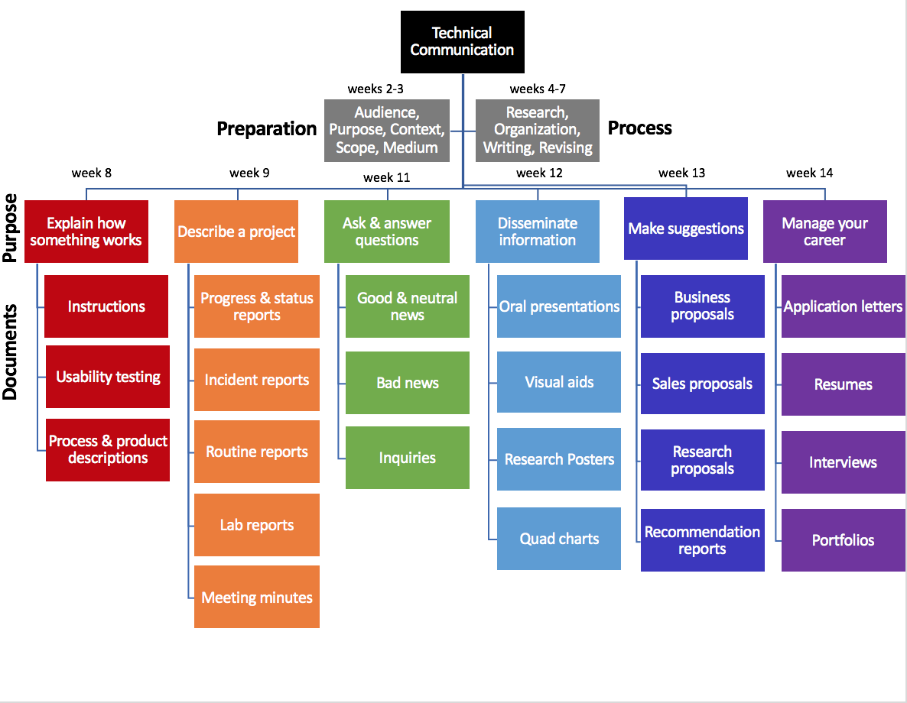
Figure 1: A concept map and schedule for a technical communication course. The organizational chart design organizes the information chronologically using rows or levels and thematically by communication purpose using columns.
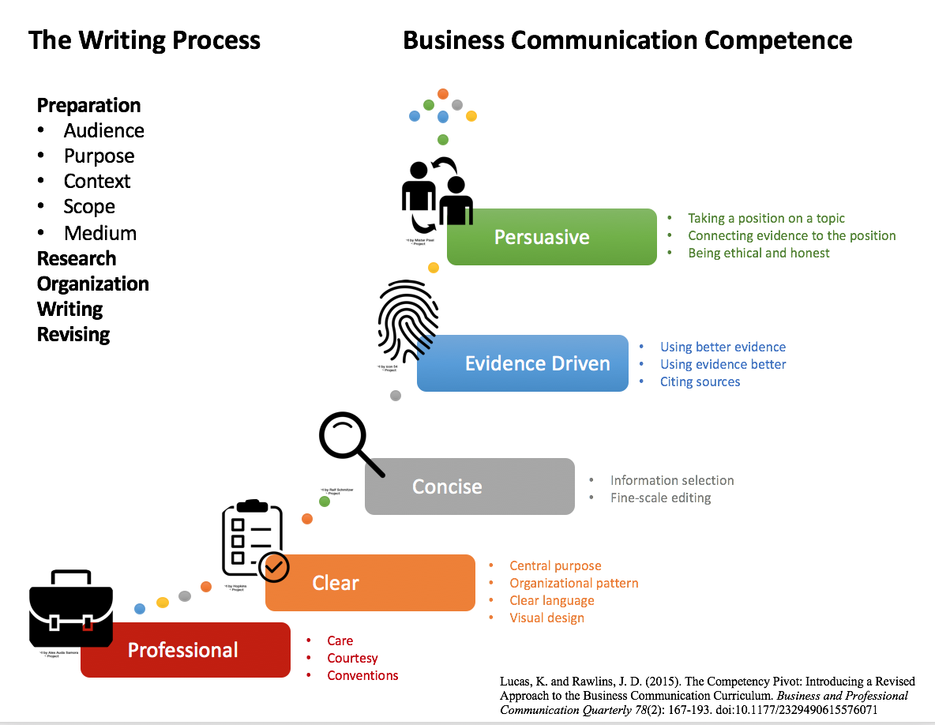
Figure 2: A concept map for a business communication course. Concepts are arranged sequentially in a hierarchical progression of increasingly complex competencies. The topics that make up each competency will be developed in rubrics.

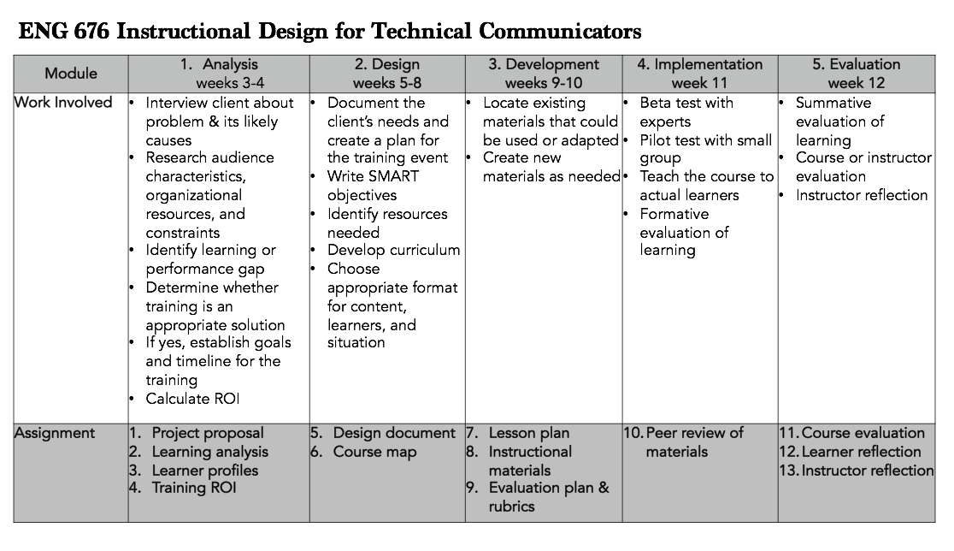
Figure 3: A concept map for an instructional design course. Concepts are arranged sequentially in columns following the ADDIE model of instructional design. Student work and corresponding assignments are described the rows below.

